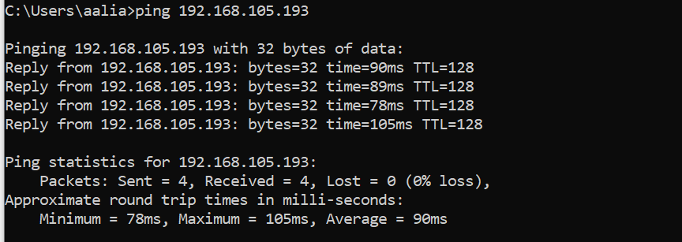

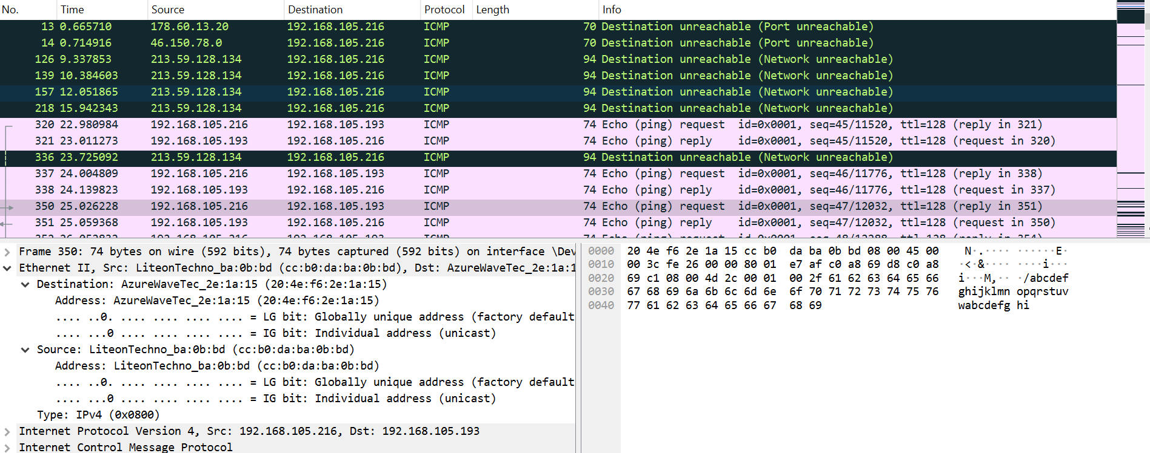

Does the source MAC address match your PC interface?
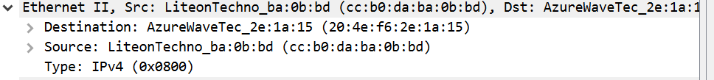

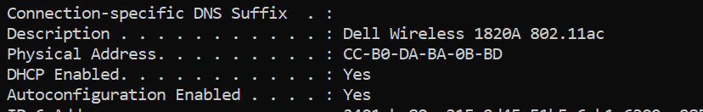

Does the destination MAC address in Wireshark match your team member MAC address?
Ans: Yes

How is the MAC address of the pinged PC obtained by your PC?
Ans: Through ICMP Message

